Guided Capstone – Blue Mountain Resort Pricing Report

Neha Choudhary

January 13, 2021

**1. Purpose, motivation and description:**

This report provide guidance to Big Mountain Resort on the competitiveness of their current ticket prices, and provides recommendations to optimize their operations with positive impact on their ticket prices and profitability.

This is accomplished using detailed data analysis and developing a robust pricing model based on other skiing mountain resorts nationwide. This pricing model guides which Big Mountain resort facilities can be stopped to lower their operating overheads and give an insight into what new facilities might help with future investments. These recommendations do not undermine the current ticket prices, in fact they do support higher ticket prices. One of the financial forecast business has at hand is to reduce the number of chairlifts that reduces their operating costs by as much as $1,540,000 for the season.

 2.    **Data acquisition:**  
 Data was used from CSV file < ski_resort_data.csv> provided by database manager and from the Metadata of columns with column descriptions. The file contained data from 330 Ski Resorts across the USA. Additional data was extracted from

< 'https://simple.wikipedia.org/w/index.php?title=List_of_U.S._states&oldid=7168473'> to gather state wise data.

3.    **Data cleaning:**

The ski data data frame had 330 rows and 27 data columns originally. The information for Blue Mountain resort was present in the data frame.. 'SkiableTerrain_ac' data was changed to 1819 to have more accurate data. About 14% of the rows were dropped due to no price data/missing values/erroneous values. As the price is the target, these rows were of no use."fastEight" column was dropped due to half the values were missing and others are the value zero(0). One of the rows that were dropped was due to incorrect data in 'yearsOpen'. The year '2019' was indetermined data and was dropped. The Box plot and Scatter plot, both show that Weekday and Weekend had similar prices but the on with missing price data was dropped. Final dataset has 277 rows and 25 columns.

For state wide statistics, some of the features were aggregated like: the total number of terrain parks, the total skiable area, the total number of days open, and the total area available for night skiing. Along side state population and state area from a different data file. These were combined together to crate a new data file – **state_summary.csv**

4.    **Exploratory Data Analysis:**

The exploratory data analysis reflects original features like Total state area, Total state population, Resorts per state, Total Skiable area, Total night skiing area, Total days open and derived features like Resorts per capita, resorts per sq mile and top states by resort density. Some of these features are more correlated than others. Using scaling the features were brought to the same approximate range for better correlation. There were multiple features to work with, hence PCA analysis was done to reduce the reduce the dimensions for better visualization.

**PCA Analysis:**

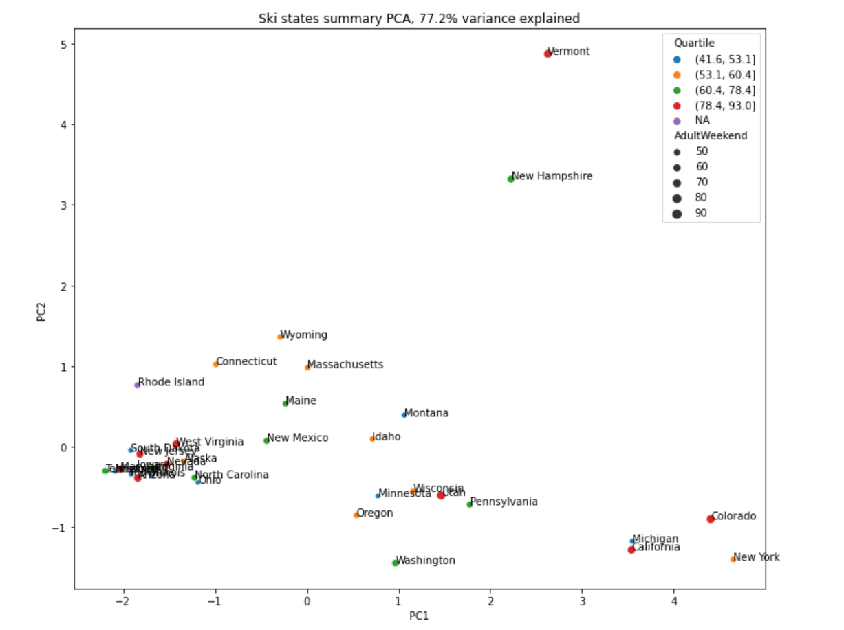

**Heat Map:**

The heat map was most insightful and it reduces the number of visualization plots to come up with a conclusion.

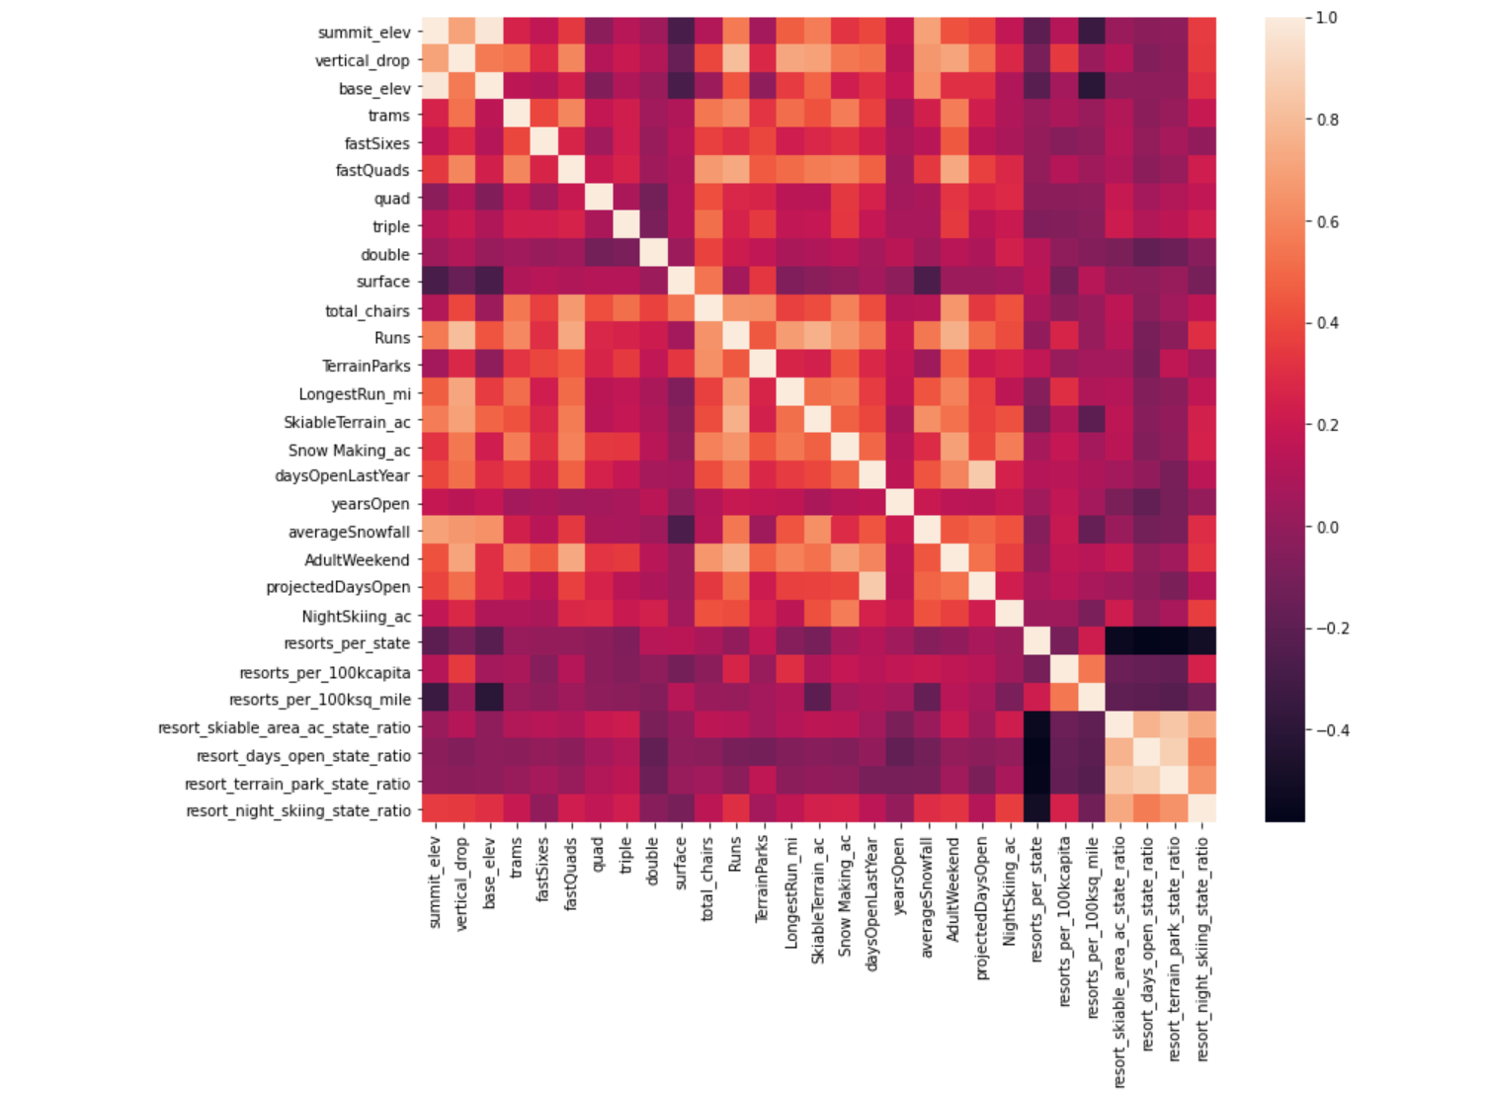

**Scatter Plots:**

Of the 32 features evaluated in the study, there were 4 key features that impacted ticket prices the most:

1. Fast Quads,
2. Runs,
3. Snow-making
4. Vertical Drop.

Based on these correlations and the features that Big Mountain Resort has, an estimated ticket price can be determined.

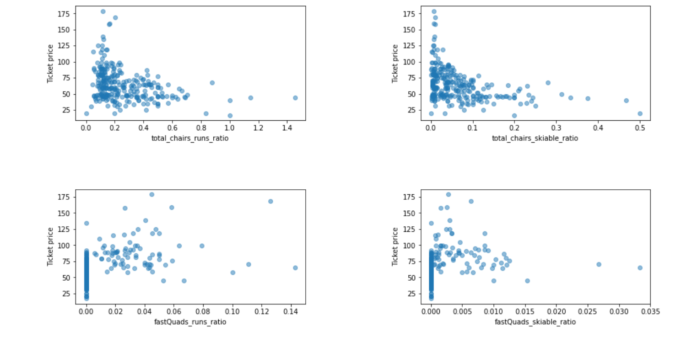

5.    **Feature Selection:**  
After sorting, the data was split into train and test, to train and test the algorithm. Mean of prices proved to be helpful in establishing a baseline for comparison, however it was not as useful or as accurate as a linear model. If you predicted ticket price by using the mean, on average you would be off by about $19. In the process of building the Linear Model, missing values were calculated with the median and mean values. If ticket prices were predicted using the linear model, they would be off by about $9. However, the initial model was overfitting and needed to be adjusted by the number of features(k). Through cross-validation, the value of k=8 to focus on: vertical_drop, Snow Making_ac, total_chairs, fastQuads, Runs, LongestRun_mi, trams, and SkiableTerrain_ac unlike previous ‘k’ values of 10 or 15.. These features fit our initial assumptions from EDA.In addition to the linear model, a Random Forest Model was developed. Like the linear model, missing values were imputed with the median and mean values. While imputing the median was helpful, it was not helpful to scale the features. The Random Forest Fodel revealed that the top four features to consider are fastQuads, Runs, Snow Making_ac, and vertical_drop. After testing both the linear model and random forest model, the project will be moving forward with the forest regression model. Comparison of the two demonstrated that performance on the test set was consistent with cross-validation results. Additionally, the cross-validation mean absolute error was lower using the random forest regressor.

6.    **Modeling:**  
Choose the best model for your case and explain the assumptions and how it compares to other models.

Currently, the target Big Mountain charges 81.00 for Adults on Weekends

The model predicted the price to be 95.87.

Even with the expected mean absolute error of 10.39, suggests there is room for a price increase of $95.87 + $10.39.The model results indicate that Big Mountain resort is currently charging less than what's price prediction suggests. However this price is still on higher side for resorts in Montana.

The Big Mountains vertical drop, snow making data, total chairs, no. of runs, area of skiable terrain area and no. of fast quad are relatively high among all resorts country-wide. We can conclude that the Big Mountain Resort offers high quality of service and ski resources to customers at competitive price.

As we know, Big Mountain Resort has recently installed an additional chair lift. This additional chair increases their operating costs by $ 1,540,000 this season. This results to operating costs of $0.88 per person/per ticket 1,540,000/(350,000visitors∗5days)]. The model too predicts increase in ticket price by 1.99 by adding a run, increasing the vertical drop by 150 feet, and installing an additional chair lift. This is enough to cover the increase in operating cost brought with additional chairlift

.As per scenario 1, business can close 5 to 8 runs rather than closing 3 or 6 runs because the predicted ticket price for closing 3-5 or 6-8 runs are the same respectively.

While, if we close more runs, more related facilities can be closed and the operational cost will be further cut down. In my opinion, the resort can point out the most unpopular runs and their related facilities.

Finally, by calculating the cut of operational cost and increase in ticket revenue, we can choose the optimal combination.

**Recommendations :**

1.Based on positive results above, Big Mountain resort can increase ticket price to a maximum of $106.40 and still be competitive with the other skiing resorts nationwide.

2.Reduce/close off one run from current runs available, selecting the least travelled/least popular run.

In analyzing different scenarios that leads to cutting down on some of the existing facilities/runs, Big Mountain resort will save operating costs and still maintain their ticket prices in fair comparison with other ski resorts nationwide.

However, the analysis assume the number of visitors will remain the same and all of them will buy 5 day tickets. This may not be true. If Big Mountain cuts down on facilities, the customers may not choose to visit the resort. If Big Mountain increase the price significantly, not all would like to pay higher and again the number of customers or the days that they buy tickets for will decrease.

Hence, we need better estimation for no. of customers and the no. of days each customer stay for another model(s) so that we can more accurately predict the revenue for these changes.

The model results indicate that Big Mountain resort is currently charging less than what's price prediction suggests. However this price is still on higher side for resorts in Montana. The vertical drop, snow making data, total chairs, no. of runs, area of skiable terrain area and no. of fast quad are relatively high among all resorts country-wide. We can conclude that the Big Mountain Resort offers high quality of service and ski resources to customers at competitive price.